 Project Design Document: Jewel Management

This document outlines the design phase for implementing a Jewel Management solution within Salesforce. It details the problem the solution addresses, the proposed approach to solving it, and the overall solution architecture. The goal is to provide a clear and comprehensive blueprint for the development and deployment of a system that effectively manages jewel-related data and processes within the Salesforce platform.

# **Problem Solution Fit:**

The current process for managing jewels (diamonds, gemstones, etc.) within the organization lacks a centralized and efficient system. This leads to several key problems:

* **Lack of Centralized Data:** Jewel information (carat, cut, clarity, color, origin, price, etc.) is scattered across various spreadsheets, emails, and potentially even physical documents. This makes it difficult to get a comprehensive overview of the jewel inventory and its associated data.
* **Inefficient Tracking:** Tracking the movement of jewels (from acquisition to sale) is

cumbersome and prone to errors. This can lead to discrepancies in inventory and difficulty in locating specific jewels.

* **Poor Reporting and Analytics:** Generating reports on jewel inventory, sales trends,

and profitability is time-consuming and often inaccurate due to the fragmented data.

* **Limited Collaboration:** Sharing jewel information and collaborating on sales opportunities is difficult due to the lack of a central platform.
* **Difficulty in Pricing and Valuation:** Determining the appropriate price for a jewel and tracking its valuation over time is challenging without a centralized system

for managing relevant data.

* **Compliance and Auditing Issues:** Maintaining accurate records for compliance and

auditing purposes is difficult due to the lack of a centralized and auditable system.

## Jewel data management ranges from scattered to centralized.

Scattered

#### Inefficient Tracking

Movement prone to errors, difficult to locate



#### Lack of Centralized Data

Data spread across multiple locations

#### Limited Collaboration

Sharing difficult without central platform

#### Poor Reporting and Analytics

Time-consuming, inaccurate due to fragmented data

#### Compliance and Auditing Issues

Difficult to maintain accurate records

#### Difficulty in Pricing and Valuation

Pricing challenging without centralized data

Centralized

**How the Solution Fits:**

The proposed Jewel Management solution in Salesforce directly addresses these problems by:

* **Centralizing Jewel Data:** Creating a dedicated object within Salesforce to store all relevant jewel information in a structured and organized manner.
* **Streamlining Tracking:** Implementing workflows and processes to track the movement

of jewels throughout their lifecycle, from acquisition to sale.

* **Enabling Robust Reporting:** Leveraging Salesforce's reporting and dashboarding capabilities to provide real-time insights into jewel inventory, sales trends, and profitability.
* **Facilitating Collaboration:** Providing a central platform for sales teams to access jewel

information, collaborate on opportunities, and manage customer interactions.

* **Improving Pricing and Valuation:** Integrating with external pricing databases or implementing custom formulas to assist in determining the appropriate price for jewels and tracking their valuation over time.
* **Ensuring Compliance**: Maintaining a complete audit trail of all jewel-related activities

to ensure compliance with relevant regulations.

## Jewel Management Process Funnel

#### Streamlined Tracking

Tracking jewel movement from acquisition to sale

#### Facilitated Collaboration

Enabling sales teams to collaborate on opportunities

#### Ensured Compliance

Maintaining audit trails for regulatory compliance

#### Robust Reporting

Providing real-time insights into jewel metrics

#### Improved Pricing

Integrating pricing databases for accurate valuation

# **Proposed Solution:**

The proposed solution involves building a custom Jewel Management application within Salesforce, leveraging its platform capabilities to address the identified problems. The core components of the solution include:

* **Custom Object: Jewel:** This object will be the central repository for all jewel-related information. It will include fields for:
  + Basic Information: Name, SKU, Description, Image
  + Gemological Data: Carat, Cut, Clarity, Color, Origin, Certification
  + Financial Data: Acquisition Cost, Selling Price, Valuation Date, Valuation Method
  + Status: Available, Sold, In Transit, Damaged
  + Location: Current Location (e.g., Vault, Store, Customer)
* **Custom Object:** Jewel Transaction: This object will track all transactions related to a jewel, such as:
  + Transaction Type: Acquisition, Sale, Transfer, Adjustment
  + Date: Transaction Date
  + Quantity: Number of Jewels Involved
  + Price: Transaction Price
* Update the status of a jewel based on its location and transaction history.
* Send notifications when a jewel's status changes or when its valuation needs to be updated.
* Generate reports on jewel inventory, sales trends, and profitability.
* **User Interface:** Custom Lightning Web Components (LWCs) to:
  + Provide a user-friendly interface for managing jewel records.
  + Display jewel images and gemological data in a visually appealing manner.
  + Facilitate the creation of jewel transactions.
* **Reports and Dashboards**: Pre-built reports and dashboards to provide real-time insights into:
  + Jewel inventory by status, location, and gemological characteristics.
  + Sales trends by jewel type, customer, and sales representative.
  + Profitability by jewel type and sales channel.
* **Integration (Optional):** Integration with external systems, such as:
  + Pricing Databases: To automatically update jewel valuations based on market prices.
  + Inventory Management Systems: To synchronize jewel inventory data.
  + Accounting Systems: To track jewel-related financial transactions.

### Jewel Management System Flowchart

Custom Object: Jewel

Custom Object: Jewel Transaction

Workflows and Automation

User Interface

Reports and Dashboards

Integration (Optional)

# **Solution Architecture:**

The solution architecture is based on the Salesforce platform and leverages its core capabilities to provide a scalable and secure Jewel Management system.

**Logical Architecture:**

The logical architecture consists of the following layers:

* + - *Presentation Layer:* This layer provides the user interface for interacting with the Jewel Management system. It consists of custom Lightning Web Components (LWCs) that are designed to be user-friendly and intuitive.
    - *Business Logic Layer:* This layer contains the business logic for managing jewels, such

as validating data, calculating prices, and updating inventory. It is implemented using Apex code and Salesforce workflows.

* + - *Data Access Layer:* This layer provides access to the underlying data stored in

Salesforce. It consists of custom objects (Jewel and Jewel Transaction) and standard Salesforce objects (Account, User).

* + - *Integration Layer (Optional):* This layer provides integration with external systems, such as pricing databases, inventory management systems, and accounting systems. It is implemented using Salesforce APIs and integration tools.

## Jewel Management System Architecture

Integration

Presentation

Business Logic Data Access

**Physical Architecture:**

The physical architecture is based on the Salesforce multi-tenant platform. The Jewel Management application will be deployed on the Salesforce cloud and will leverage its infrastructure for scalability, security, and reliability.

* + - *Salesforce Platform:* The Jewel Management application will be built and deployed on the Salesforce platform.
    - *Salesforce Database:* The jewel data will be stored in the Salesforce database.
    - *Salesforce AppExchange (Optional):* Custom components or pre-built solutions from the AppExchange may be used to enhance the functionality of the Jewel Management application.
    - *External Systems (Optional):* Integration with external systems will be implemented

using Salesforce APIs and integration tools.

## Jewel Management Application Architecture

Salesforce Database

Salesforce Platform

Salesforce AppExchange

External Systems

**Data Model:**

The data model is designed to capture all relevant information about jewels and their transactions. The core entities in the data model are:

* + - Jewel: Represents a single jewel.
    - Jewel Transaction: Represents a transaction involving one or more jewels.
    - Account: Represents a customer or vendor.
    - User: Represents a user of the Jewel Management system.



Jewel Jewel Transaction

Account

User

**Security Architecture:**

Security is a critical aspect of the Jewel Management solution. The following security measures will be implemented:

* + - Role-Based Access Control: Users will be assigned roles that determine their access to jewel data and functionality.
    - Field-Level Security: Access to sensitive fields, such as acquisition cost and selling

price, will be restricted based on user roles.

* + - Data Encryption: Sensitive data will be encrypted at rest and in transit.
    - Audit Logging: All jewel-related activities will be logged for auditing purposes.
    - Salesforce Security Features: Leveraging Salesforce's built-in security features, such as password policies, session management, and IP address restrictions.



Role-Based Access

Field-Level Security

Data Encryption

Audit Logging

Salesforce Security

This document provides a high-level overview of the design phase for the Jewel Management solution in Salesforce. Further details will be elaborated in subsequent design and development phases.

### Jewel Management Design Process

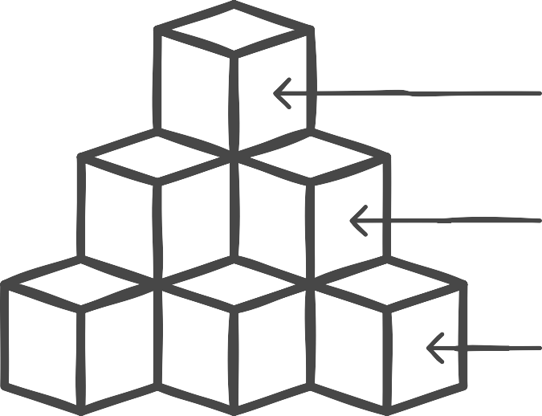Development Phase Detailed Design Design Overview